**Ultrasonic Module HC-SR04**

The ultrasonic sensor works on the principle of SONAR and RADAR system which is used to determine the distance to an object.

### Ultrasound

Ultrasound is high-pitched sound waves with frequencies higher than the audible limit of human hearing.

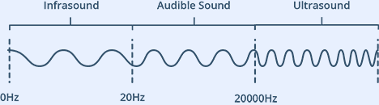

Human ears can hear sound waves that vibrate in the range from about 20 times a second (a deep rumbling noise) to about 20,000 times a second (a high-pitched whistling). However, ultrasound has a frequency of over 20,000 Hz and is therefore inaudible to humans.

At its core, the HC-SR04 Ultrasonic distance sensor consists of two [ultrasonic transducers](https://en.wikipedia.org/wiki/Ultrasonic_transducer). The one acts as a transmitter which converts electrical signal into 40 KHz ultrasonic sound pulses. The receiver listens for the transmitted pulses. If it receives them it produces an output pulse whose width can be used to determine the distance the pulse travelled. As simple as pie!

The sensor is small, easy to use in any robotics project and offers excellent non-contact range detection between 2 cm to 400 cm (that’s about an inch to 13 feet) with an accuracy of 3mm. Since it operates on 5 volts, it can be hooked directly to an Arduino or any other 5V logic microcontrollers.

Here are complete specifications:

|  |  |
| --- | --- |
| Operating Voltage | DC 5V |
| Operating Current | 15mA |
| Operating Frequency | 40KHz |
| Max Range | 4m |
| Min Range | 2cm |
| Ranging Accuracy | 3mm |
| Measuring Angle | 15 degree |
| Trigger Input Signal | 10µS TTL pulse |
| Dimension | 45 x 20 x 15mm |

## HC-SR04 Ultrasonic Sensor Pinout

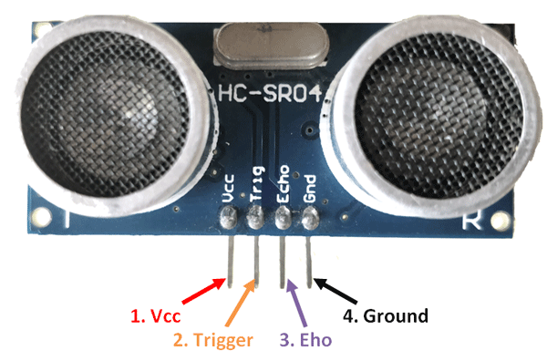

VCC is the power supply for HC-SR04 Ultrasonic distance sensor which we connect the 5V pin on the Arduino.

Trig (Trigger) pin is used to trigger the ultrasonic sound pulses.

Echo pin produces a pulse when the reflected signal is received. The length of the pulse is proportional to the time it took for the transmitted signal to be detected.

GND should be connected to the ground of Arduino.

## WORKING

It all starts, when a pulse of at least 10 µS (10 microseconds) in duration is applied to the Trigger pin. In response to that the sensor transmits a sonic burst of eight pulses at 40 KHz. This 8-pulse pattern makes the “ultrasonic signature” from the device unique, allowing the receiver to differentiate the transmitted pattern from the ambient ultrasonic noise.

The eight ultrasonic pulses travel through the air away from the transmitter. Meanwhile the Echo pin goes HIGH to start forming the beginning of the echo-back signal.

In case, If those pulses are not reflected back then the Echo signal will timeout after 38 mS (38 milliseconds) and return low. Thus a 38 mS pulse indicates no obstruction within the range of the sensor.



If those pulses are reflected back the Echo pin goes low as soon as the signal is received. This produces a pulse whose width varies between 150 µS to 25 mS, depending upon the time it took for the signal to be received.



The width of the received pulse is then used to calculate the distance to the reflected object. This can be worked out using simple distance-speed-time equation, we learned in High school. In case you forgot, an easy way to remember the distance, speed and time equations is to put the letters into a triangle.

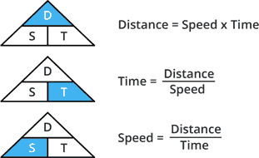

Let’s take an example to make it more clear. Suppose we have an object in front of the sensor at an unknown distance and we received a pulse of width 500 µS on the Echo pin. Now let’s calculate how far the object from the sensor is. We will use the below equation.

Distance = Speed x Time

Here, we have the value of Time i.e. 500 µs and we know the speed. What speed do we have? The speed of sound, of course! Its 340 m/s. We have to convert the speed of sound into cm/µs in order to calculate the distance. A quick Google search for “speed of sound in centimeters per microsecond” will say that it is 0.034 cm/µs. You could do the math, but searching it is easier. Anyway, with that information, we can calculate the distance!

Distance = 0.034 cm/µs x 500 µs

But this is not done! Remember that the pulse indicates the time it took for the signal to be sent out and reflected back so to get the distance so, you’ll need to divide your result in half.

Distance = (0.034 cm/µs x 500 µs) / 2

Distance = 8.5 cm